**1. INTRODUCTION**

**1.1. Organization Profile**

Infosys Limited (formerly Infosys Technologies Limited) is an Indian multinational corporation that provides business consulting, information technology and outsourcing services. It has its headquarters in Bangalore, India. Infosys is the second-largest Indian IT services company by 2016 revenues, and the largest employer of H-1B visa professionals in the United States. On January 12, 2017, its market capitalization was $34.38 Billion. It provides software development, maintenance and independent validation services to companies in banking, finance, insurance, manufacturing and other domains. On 15 January 2016,Infosys had 1,045 clients across 50 countries.

Infosys has a global footprint with offices and development centers across the world.

In 2012, Infosys announced a new office in Milwaukee, Wisconsin to service Harley-Davidson, being the 18th international office in the United States. Infosys hired 1,200 United States employees in 2011, and expanded the workforce by an additional 2,000 employees in 2012. One of its known products is Finacle which is a universal banking solution with various

modules for retail & corporate banking.

key products are:-

* Mana - Knowledge based AI platform
* Infosys Information Platform (IIP)- Analytics platform
* Edge Verve Systems
* Finacle- Global banking platform by Edge Verve Systems
* Panaya Cloud Suite
* Skava

**1.2 Existing System**

The existing system in Infosys Mysore Development Centre faces several issues in booking and cancellation of grounds. They have to request a membership card for that and wait for the approval from other higher officials. And if they want to play they need to book the grounds before a week from that particular day. All of the employees register themselves and the work was done manually. In order to avoid this problem the system was developed.

**1.3 Proposed System**

The proposed system is developed to book the grounds for Infosys employees so that they can play in their leisure time. They don’t need to have a membership card with them and they can use their employee id or intern id to book the grounds. And they can pre-book the slots any time they want but before that particular slot is booked by another person. And the cancellation process is also have same methodology like booking.

**1.3.1 Advantages of Proposed System**

The proposed system has the following advantages,

* Using LDAP, employee can automatically log in.
* Standardization of Works.
* User friendly UI.
* Reduced Cost.
* Reduce Manual Work.

**2. SYSTEM ANALYSIS**

**2.1. Feasibility Study**

The feasibility of the project is analyzed in this phase and business proposal is put forth with a very general plan for the project and some cost estimates. During system analysis the feasibility study of the proposed system is to be carried out. This is to ensure that the proposed system is not a burden to the company. For feasibility analysis, some understanding of the major requirements for the system is essential.

Three key considerations involved in the feasibility analysis are

* Economical feasibility
* Technical feasibility
* Social feasibility

**2.1.1. Economical Feasibility**

This study is carried out to check the economic impact that the system will have on the organization. The amount of fund that the company can pour into the research and development of the system is limited. The expenditures must be justified. Thus the developed system as well within the budget and this was achieved because most of the technologies used are freely available. Only the customized products had to be purchased.

### **2.1.2. Technical Feasibility**

This study is carried out to check the technical feasibility, that is, the technical requirements of the system. Any system developed must not have a high demand on the available technical resources. This will lead to high demands on the available technical resources. This will lead to high demands being placed on the client. The developed system must have a modest requirement, as only minimal or null changes are required for implementing this system.

**2.1.3. Social Feasibility**

The aspect of study is to check the level of acceptance of the system by the user. This includes the process of training the user to use the system efficiently. The user must not feel threatened by the system, instead must accept it as a necessity. The level of acceptance by the users solely depends on the methods that are employed to educate the user about the system and to make him familiar with it. His level of confidence must be raised so that he is also able to make some constructive criticism, which is welcomed, as he is the final user of the system.

**2.2 Use Case Diagram**

**2.2.1. Primary Use Case diagram**



**Fig 2.2.1** Primary Use Case Diagram

**2.2.2. Secondary Use Case Diagram**



**Fig 2.2.2** Secondary Use Case Diagram

**3. SYSTEM REQUIREMENTS SPECIFICATION**

**3.1. Scope**

The scope for this project is, it is used by Infosys Mysore Development Center employees and interns to book and cancel Infosys play grounds at the Mysore DC.

**3.2. Functional Requirements**

* Employees can login in the sports portal once they received their official employee number.
* They can book the play ground if it is not booked by some other employee.
* Booking is done based on First Come First Serve manner.
* She/he can cancel the already booked ground before the day of playing.
* The can view the booked slots of other employees in the portal.
* They can also generate the report for their booking.
* They can also modify their booked slot if the ground they want is not booked by somebody else.

**3.3. Performance Requirements**

Performance Requirements (PR) are necessary for system design and development. A Performance Requirement is generally in terms of number of users, this system can handle.

**3.3.1** **Functionality**

The proposed system will contain all the general functions mentioned in requirements. It also ensures the interoperability and accuracy.

**3.3.2** **Reliability**

This System provides reliability by giving accurate information about particular slot booking. The system also maintains the records dynamically.

**3.3.3 Reusability**

In this System, to reduce implementation time, reusable modules and classes are used, that is, a segment of source code that can be used again to add new functionalities with slight or no modification.

**3.3.4. Flexibility**

Proposed system provides more flexibility by the way of adopting the changes in the project because it has some algorithm implement, it can change in future easily.

**3.3.5.** **Speed**

The proposed system speed is high, as it yields the results within 5 sec and also navigating from one page to other.

**3.3.6** **Performance**

The proposed system has fast response to the input data and has minimum delay for every operation it performs.

**3.4. Software Requirements**

* Operating system : Windows 7.
* Front End : JDeveloper 11g.
* Coding Language : Java.
* Back End : Oracle.

**3.5. Hardware Requirements**

* System : Pentium IV 2.4 GHz.
* Hard Disk : 100 MB.
* Ram : 4 GB.

**3.6. Technologies Used**

**Front End:** JDeveloper 11g.

Oracle JDeveloper is a free integrated development environment that simplifies the development of Java-based applications addressing every step of the application lifecycle.

JDeveloper offers complete end-to-end development for Oracle's platform and Oracle's applications.

**Back End:** Oracle.

The Oracle RDBMS stores data logically in the form of table spaces and physically in the form of data files ("data files").Table spaces can contain various types of memory segments, such as Data Segments, Index Segments, etc. Segments in turn comprise one or more extents. Extents comprise groups of contiguous data blocks. Data blocks form the basic units of data storage.

**Designing Tool:** Beta Rational Rose Enterprise Edition 7.0.0.

The Rational Rose family of products is a set of UML modeling tools for software design. The Unified Modeling Language (UML) is the industry-standard language for specifying, visualizing, constructing, and documenting the artifacts of software systems. It simplifies the complex process of software design, creating a "blueprint" for construction of software systems.

**4. SYSTEM DESIGN**

**4.1. System Architecture Diagram**

System design is the major process which can be termed as the backbone in the development of any software product. Design phase in any project will consider the results of the analysis phase and comes out with the prototype of the product, which is almost similar to the product which is being developed.

Database

Lightweight Directory Access Protocol (LDAP)

**Fig 4.1** Architecture Diagram

**4.2. DATAFLOW DIAGRAM**

Dataflow is the movement of data in a system from a point of origin to a specified destination indicated by line or arrow. Dataflow diagram is the graphical representation of the data movements, processes and files (data stores) used in support of information systems.

The data flow diagram (DFD) is one of the most important tools used by system analysts. Data flow diagrams are made up of a number symbols, which represent system components. Most data flow modeling methods use four kinds of symbols. These symbols are used to represent four kinds of system components. Processes, data stores, data flows and external entities.

**4.2.1 DFD level 0:**

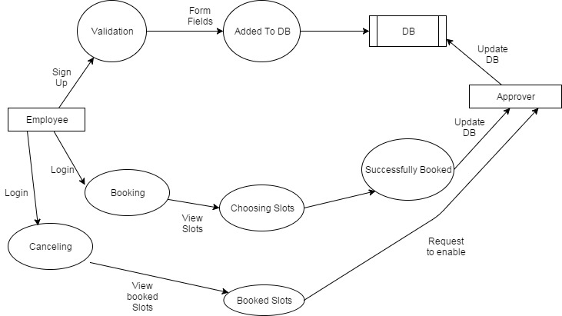

**Fig 4.2.1** DFD Level 0

**4.2.2 DFD level 1:**



**Fig 4.2.2** DFD Level 1

**4.3. Entity Relationship Diagram**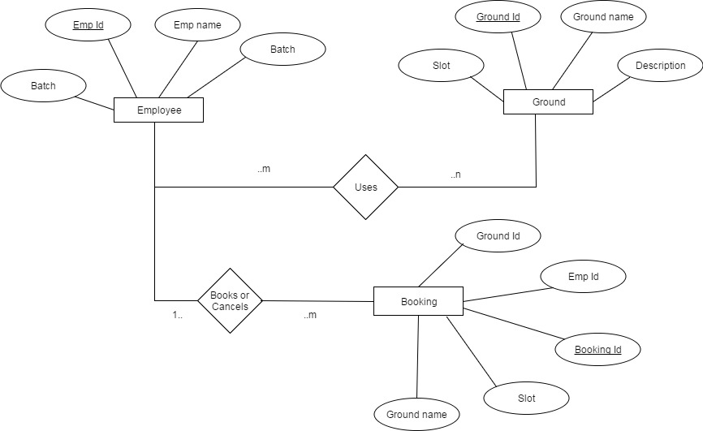

**Fig 4.3** ER Diagram

**4.4. Process flow Diagram**

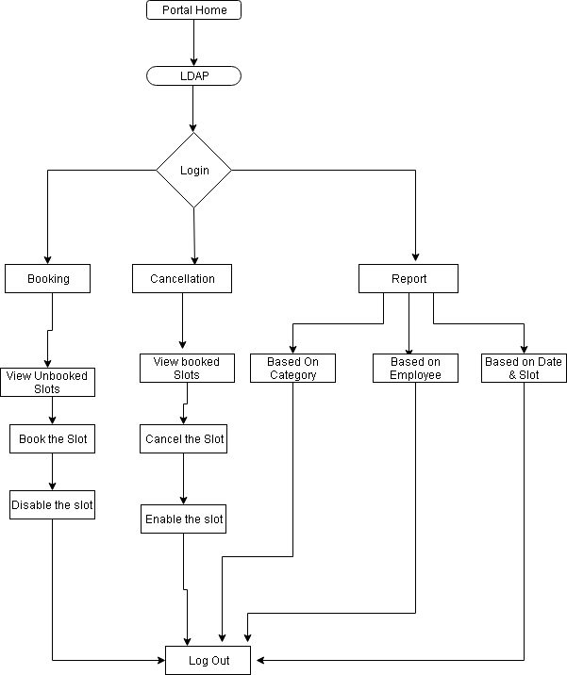

**Fig 4.4** Process Flow Diagram

**4.5. Logical Design using UML**

**4.5.1. Sequence Diagram-Booking**



**Fig 4.5.1** Sequence Diagram-Booking

**4.5.2. Sequence Diagram-Cancelling**



**Fig 4.5.2** Sequence Diagram -Cancelling

**4.5.3. State Chart Diagram**



**Fig 4.5.3** State Chart Diagram

**4.5.4. Activity Diagram**

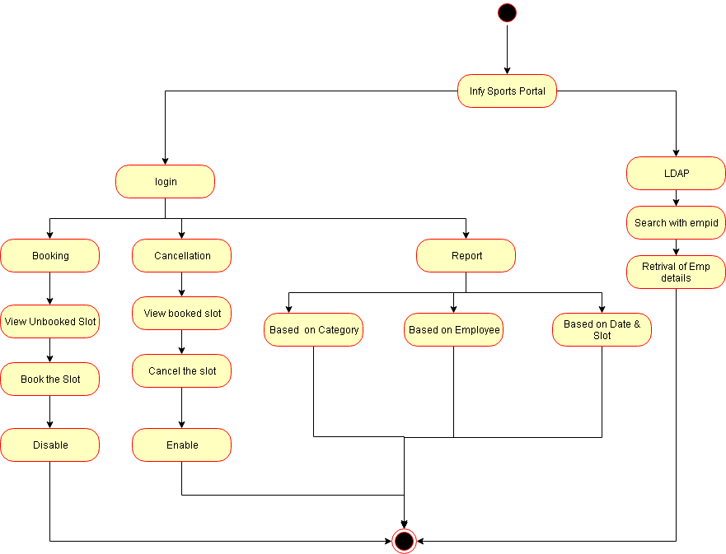

**Fig 4.5.4** Activity Diagram

**4.6. MODULE DESCRIPTION**

**4.6.1. Booking**

In Booking Module, based on the current system date, the dates of next three days are retrieved and it is visible to the user in booking user interface.

Once the user chooses a date, the slots will be displayed to user. Each day has two slots (morning and evening).

User can book any of the two slots based on the availability, after the booking was successful, it is disabled in the database so that no one can book it.

**4.6.2.** **Cancellation**

In Cancellation Module, the booked slots by him/her is viewed, they can cancel or modify the slots.

While cancelling the slots should be enabled for other users to book.

While modifying, the user can select other slots if it is available.

**4.6.3. Viewing**

The viewing is based on three types

* View by Category.
* View by Employee.
* View by Date & Slot.

View by Category:

The details are generated based on the ground type like Tennis ground, Cricket ground, Basket ball ground, Volley ball ground etc.,

View by Employee:

The slots booked by the particular employee are viewed in the tabular format.

View by Date & Slot:

The details are generated based on the selection of particular date and slot.

**4.6.4. Reporting**

In Reporting module, the details are exported as a Excel document or Portable Document File(PDF) or Word document.

**4.7. Database Design**

**LDAP (Infosys directory)**

|  |  |  |  |
| --- | --- | --- | --- |
| **Fieldname** | **Data Type** | **Length** | **Key** |
| EmpId | Varchar | 7 | Primary Key |
| EmpName | Varchar | 30 | **-** |
| ContactNo | Number | 12 | **-** |
| Email.Id | Varchar | 20 | **-** |
| Department | Varchar | 10 | **-** |

**Login**

|  |  |  |  |
| --- | --- | --- | --- |
| **Fieldname** | **Data Type** | **Length** | **Key** |
| EmpId | Varchar | 7 | Primary Key |
| Password | Varchar | 20 | **-** |

**Booking**

|  |  |  |  |
| --- | --- | --- | --- |
| **Fieldname** | **Data Type** | **Length** | **Key** |
| BookingId | Varchar | 6 | Primary Key |
| GroundId | Varchar | 3 | Foreign Key |
| EmpId | Varchar | 7 | **-** |
| GroundName | Varchar | 20 | **-** |
| BookingDate | Date | - | **-** |
| Slot | Varchar | 5 | **-** |
| Status | Boolean | - | **-** |

**Ground Details**

|  |  |  |  |
| --- | --- | --- | --- |
| **Fieldname** | **Data Type** | **Length** | **Key** |
| GroundId | Varchar | 3 | Primary Key |
| GroundName | Varchar | 20 | **-** |
| Description | Varchar | 30 | **-** |
| Type | Varchar | 10 | **-** |

**5.TESTING**

* 1. **Testing Objective**

Software testing is an important phase in the development of the system. Generally, system testing involves testing integration of each module in the system. The objective while testing the system is to test the discrepancies between the system and the original objective. The quality of an information system depends on its design, development and implementation.

Testing is the most important activity in the development phase. Testing is the process of finding errors or bugs in the system. Testing ensure that the user’s needs are satisfied. In other words it is a process by which one detects the defects in the system.

* Unit testing
* Integration testing
* User Interface Testing
* Functional Testing
* System Testing

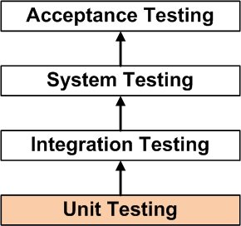

* 1. **Unit Testing**

Unit testing is the testing of each module and the integration of the overall system is done.  Unit testing becomes verification efforts on the smallest unit of software design in the module.  This is also known as ‘module testing’.  The modules of the system are tested separately.  This testing is carried out during the programming itself.  In this testing step, each model is found to be working satisfactorily as regard to the expected output from the module.  There are some validation checks for the fields.  For example, the validation check is done for verifying the data given by the user where both format and validity of the data entered is included.  It is very easy to find error and debug the system

**Table 5.2** Unit Testing

|  |  |  |  |  |  |
| --- | --- | --- | --- | --- | --- |
| **S.No.** | **Test Condition** | **Test Case** | **Expected**  **Output** | **Actual**  **Output** | **Result** |
| 1 | Wrong username or password | Enter the invalid username or password | Error | Authentication failed | Pass |
| 2 | Invalid booking details | Enter Invalid Booking details  eg: Invalid Date | Date already booked | Error | Pass |
| 3 | Check Empty Fields | Empty Field | Please fill all the fields | Please fill all the fields | Pass |
| 4 | Check for the employee record in Infosys directory. | Search Employee | Employee record not found | Employee record not found | Pass |

**5.3 Integration Testing**

Integration testing is the systematic technique of for constructing the program structure while conducting test to uncover errors associated with integrating after unit testing each modules are integrated to from one fine system.

All the modules when unit tested will work properly but after integrating the data can cause error. One module can have an inadvertent, adverse effect on another; sub functions when combined may not produce the desired major function; global data structures can cause problems, etc. Hence, the objective of integration testing is to take unit tested modules and build a final program structure. In this project, modules are combined to find the overall performance of the system.

Inthis project the modules are integrated properly, the emphasis being and testing interfaces between modules .internal and external interfaces are tested as each module is incorporated into the structure .this test is designed to uncover errors associated with local are global data structures are conducted .

It is also designed to verify performance levels established during software design are conducted

Thus all these modules are combined, verified and the information about the items are properly carried on to the next module and then it is checked.

* 1. **User Interface Testing**

Tests are often generated using a components interface. Certainly, the interface itself forms a part of the components requirements and hence this form of testing is often called black box testing. However, the focus on interface leads us to consider interface testing in its own right. Techniques such as pair wise testing and interface mutation are used to generate tests from a components interface specification**.**

* 1. **Performance Testing**

Performance testing is designed to test the run-time performance of the software within the context of an integrated system.

Performance testing (Navigation Testing) in the “indoor localization” is done from the first till the end of the system process to check out the performance to know whether it satisfies the user requirements.

* 1. **System Testing**

After every module is integrated, the system test is performed. System testing does not test the software but the integration of each module in the system. It also tests to find discrepancies between the system and its original objective, current specifications and systems documentation. The primary concern is the compatibility of individual modules. Finally after the completion of all the modifications the end users must verify the project, whether it is satisfying their need or not.

1. **IMPLEMENTATION**

Implementation forms an important phase in the development life cycle. This phase of software development is concerned with translating design specification into working model. Implementation is the final phase in achieving a successful system and in giving the users confidence that the system will work efficiently. Usually, this phase is the longest of all life cycle phases and is characterized by four distinct changes.

* Changeover
* Routine maintenance stage
* User-acceptance review
* Post implementation reviews

**CHANGEOVER**

Initially, the new system must be introduced the business activity stream. This state is called Changeover. The changeover transaction may take weeks or even months.

**ROUTINE MAINTENANCE STAGE**

After the completion of changeover, the system enters the operation and routine maintenance stage. Early in this stage, the evaluation should be made based on performance measurements that determine whether the specific benefits claimed for the system have been achieved.

**USER ACCEPTANCE / POST IMPLEMENTATION**

After this system was implemented, a user-acceptance review was conducted to gather information for the maintenance of the system. This review was done to determine whether the system has met the expectations and objectives of the user.

As new activities begin, or change in the procedures occur due to the internal or external factors the system is prone for modification needs. Thus, for the maintenance requirements, this post implementation reviews provides the first source of the users.

1. **CONCLUSION**

In this Project, We implemented the Infosys Mysore DC Sports Portal as a Fusion web application using Oracle Application Development Framework (ADF).All the requirements of the employees are satisfied and they are able to book and cancel the play grounds quickly and easily.

This system has the following features,

* Using LDAP, employee can automatically log in.
* Standardization of Works.
* User friendly UI.
* Reduced Cost.
* Reduce Manual Work.

**Future Enhancement**

Now this project is only implemented for Infosys Mysore Development Center only. In Future this one moved to shared database so that it can be useful in developing portal for all the development and training centers of Infosys.

**8. BIBLIOGRAPHY**

**References Made From:**

1. Roger S Pressman**, “**Software Engineering**-** A Practitioner's Approach**”,**7th Edition, McGraw Hill.

2. Jeyamala D, ”Object Oriented Analysis and Design”. 1st Edition, McGraw Hill.

3. Java: The Complete Reference, Ninth Edition by Herbert Schildt.

4. Nick Herbaladis: Oracle JDeveloper 11gR2 Cookbook.

**Sites Referred:**

1. <http://www.oracle.com/technetwork/developer>
2. <http://www.stackoverflow.com>
3. <http://www.quora.com>